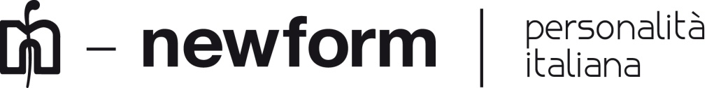

Newform at the Design Week in Brera

The eagerly-awaited Fuorisalone returns in Milan and Newform will be among the protagonists in the fascinating district of Brera, an iconic place in the city for Art, Design and more.

The brand will show its new products and will impress visitors with its creativity. This year Newform turns into new colors, new finishes that lend to products shades and reflections that enhance materials and emphasize forms.
The showroom in Via Fiori Oscuri 3, will be open from 4th to 8th April, from 3 pm to 10 pm and guests will be welcome with an happy hour and during the evening they will talk about the latest trends.
A conceptual installation will exhibit the latest proposals of Newform to exalt the aesthetic quality of products, focusing on their own projects and offering to the client a customized and personalized service.
Newform will take part to the “White in the city” event and wait for you at Palazzo Cusani in the "White on White" project, conceived by Alberto Apostoli: a wellness exhibition itinerary where the Aqualite collection, born by a collaboration between the architect and the brand, will be in the spotlight with a special white finish, to emphasize the value of this color as a symbol of purity and essential. Aqualite shower heads, controls and mixers will be displayed in the Palace, and visitors could see and touch the technological innovation and ahestetic care of products.
During the design week Newform will participate in the event "Officina dell'Abitare e dello Stile" projected by the Address Design Studio and the fashion stylist Gianni Tolentino. They will transform the historic Cloister of St. Marco’s Church in an emotional space in an architectural and artistic location. The heart of this project is the installation of a creativity kitchen into an unique wood an crystal cell where the Newform mixer O'Rama with black matt finishing will enhance the environment.
This year Newform proposes a rich schedule of events and initiatives during the Fuorisalone in order to impress visitors by playing with new ideas and visions.

Newform Company Profile
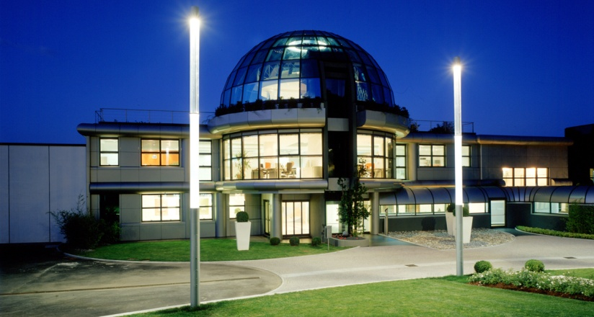
Exclusivity, innovation and quality, together with attention to detail, are the hallmarks of the research for Newform. A story that passes through time, swinging between the past and the future. Newform is a guarantee of brand awareness and it is enhanced by a broader philosophy, identifying a real lifestyle able to give a touch of class and modernity to the bathroom and the kitchen. Research is the cornerstone of the great success of the company: the design conceived as the foundation of the product, the finest materials used and the eco-friendly technology create a top quality product, sophisticated and practical. The application of new technologies and the desire to express a touch of personal character make water available in new forms. That’s the philosophy adopted by Newform, with the aim to offer a product able to meet the needs of contemporary time, in a ritual approach to the bathroom and kitchen spaces.
Newform offers a wide range of items, from faucets to ceramics, besides design oriented accessories that give a touch of style to the bathroom. The good design of the company allows you to create a unique and complete room for beauty lovers.
Newform is also wellness. The brand focuses on all those who love taking care of themselves and giving moments of gratification, proposing them exclusive products: the Wellness collections, to feel lost in a wonderful sensorial experience.
Newform Press Office
Linda Barbolan
Public & Media Communication
Newform Spa
media@newform.it

